29.03.Тема: Профессии в СМИ

Цель: повторить материал «Модальные глаголы», развивать лексико- грамматические навыки в рамках изучаемой темы  
  
1. Выучить лексику урока:

People in the mass media:  
show and quiz hosts  
correspondents  
editors  
operators and photographers  
newsreaders  
and commentators  
interviewers  
broadcasters

and journalists

director — режиссер

reporter — репортер

presenter — ведущий

producer — продюсер

sound engineer — инженер звука

editor — редактор

newsreader — диктор

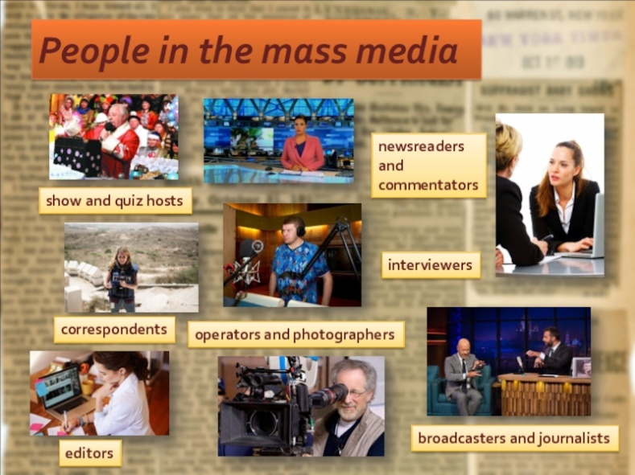

2. Письменно выполнить упр.4 стр.112.

<https://www.youtube.com/watch?v=gtvMbcVUdqU>

3. Повторить материал «Модальные глаголы» по материалу видеоурока

<https://www.youtube.com/watch?v=zqRLJASt2ps>

4. Выполнить упр.1 стр.150 письменно.  
5. Домашнее задание: прочитать и перевести сочинение о профессии журналиста, выписать из сочинения виды деятельности журналиста

## *Profession of Journalist*

I have decided to become a journalist. I think it is an interesting and useful profession.

I like to watch TV, listen to the radio, read newspapers and magazines. I like everything which is connected with mass media.

I have a hobby. My friends and I are publishing a small newspaper once a month in our school. We write articles about school events, life of young people, jokes, draw pictures and caricatures. My favourite school subjects are History and Literature.

I like the profession of a journalist. They meet many people. They try to understand what is going on in the world, or the country, or the city and try to explain it to other people.

I think that the work of a journalist is very much like that of a historian. A historian studies and tries to explain events of the past and a journalist does the same about the present.

But for me to be a journalist is much more interesting than to be a historian because you deal with real events that are happening right now so you can even influence them.

So journalists can influence the history. That is why I want to be a journalist.

Работы присылать на почту [**svetlanalashina@mail.ru**](mailto:svetlanalashina@mail.ru)