Они были первыми. Выдающиеся люди прошлого

Цель: развитие языковой компетентности учащихся по теме «Вчера, сегодня, завтра»; учить логически строить высказывание на основе прослушанной и переработанной информации; развивать кругозор учащихся, творческие навыки, грамматические навыки (Past Simple)

Тип урока: комплексное усвоение знаний

Good morning, children! How are you? What is the day today? What is the month?

Friday, the seventeenth of February

Class-work\Homework

1. Составьте повествовательные, вопросительные и отрицательные предложения в прошедшем простом времени по примеру:

1)People (like) to spend their free time in the saloons.

+ People liked to spend their free time in the saloons.

? Did people like to spend their free time in the saloons.

- People didn`t like to spend their free time in the saloons.

2)My friend (walk) his dog in the park yesterday.

+

?

-

3)Ann(give)me a book 2 days ago

+

?

-

2. Disneyland heroes

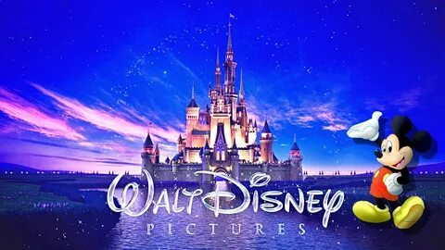

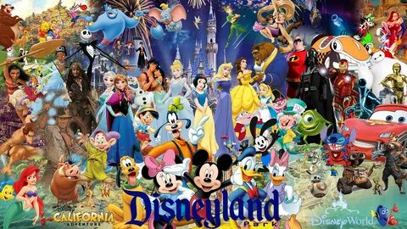

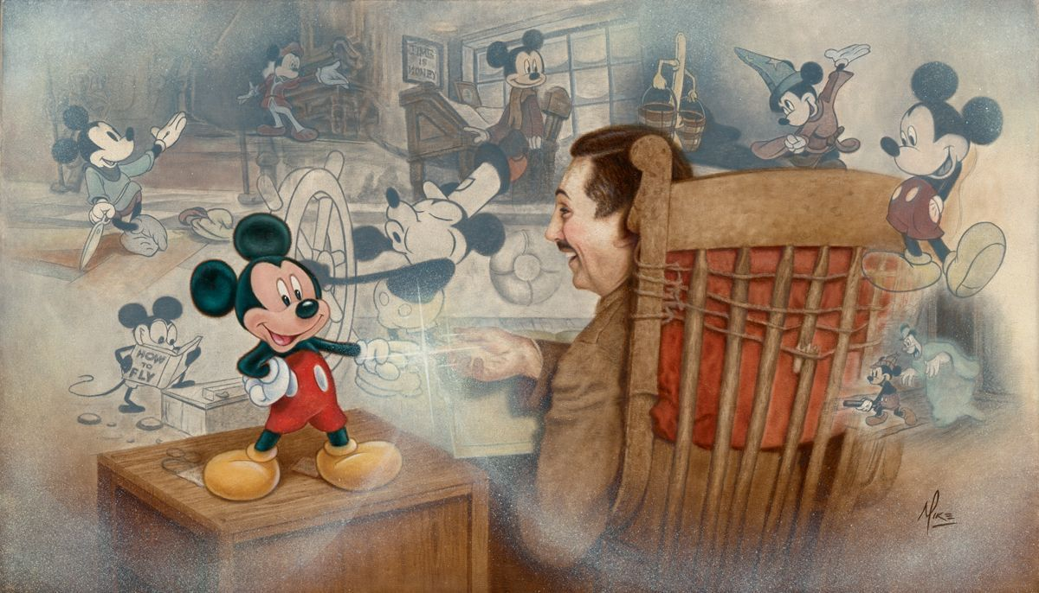

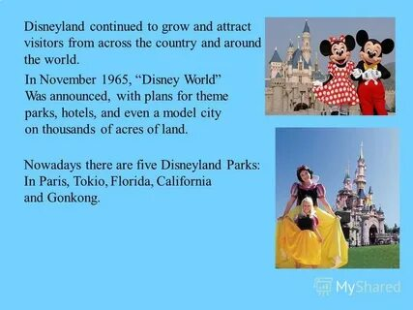

1. Read and translate the text (p70). Match the paragraphs to the headings (ex2 p70)
2. Answer the questions:

When was Walt Disney born?

How wad was he when he left for Hollywood?

When did he create Mickey Mouse?

How many films did he make?

1. Write a short biography of a famous person of the past (60-80 words)

